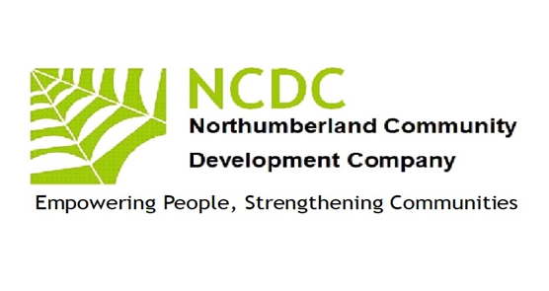
Empowering People
Strengthening
Communities
Empowering People
Strengthening
Communities
Annual Report 2017 –2018

Chairman’s report
This year has seen NCDC continue our redevelopment as we managed several complementary projects for which we raised funds from a number of sources.
I would like to thank everyone who has helped NCDC through this year of transition our staff team have delivered magnificent results. The team has recently expanded to deliver these projects with the addition of Sarah Sunderland and Lynn Johnston. To continue to deliver quality accredited learning, NCDC is working with a pool of tutors, assessors and internal verifiers, headed by Janet Cresswell, with support from Carol Burnett and Julia Lyford.
NCDC continues to work with volunteers, especially as Digital Champions, to enhance services. NCDC is grateful for their contributions of time, skills and expertise and to my colleagues on the board who have increased their commitment to steer the organisation forward.
I would also thank our funders who include Peoples Health Trust, Princes Countryside Fund, The Good Things Foundation, Awards 4 All, Tyne and Wear Community Foundation/Comic Relief, NatWest Skills and Opportunities Fund, and Gateshead Council (ESF). Our Board has worked to produce a realistic five-year plan though which we have consolidated and will now grow our organisation. We are focusing on our existing strengths in Inclusion, Learning, Networking and Economic Enterprise. If you would like to find out more about working with NCDC, please contact me. John McGough, Chair. 07885303166

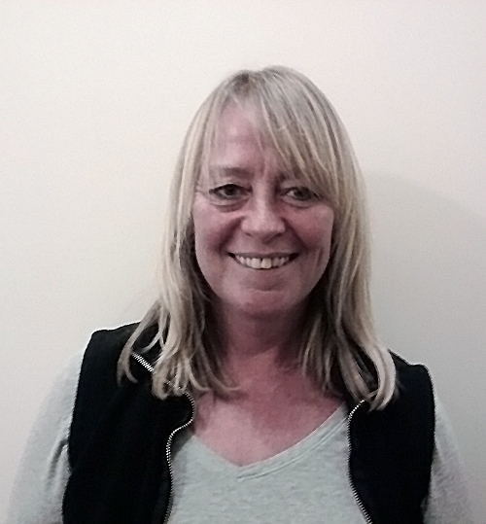
Pat Barber
John McGough
Cath Stocks
Jim Robertson

Our Work 2017-2018

Inclusion
NCDC continues to be a recognised UK Online Centre offering IT support to individuals across the county to increase their access to IT skills. Gordon Stewart has continued his support of our digital agenda/needs assisting us to improve our IT skills and confidence through helping us in relaunching our webpage and social media profiles
NCDC is a champion of rural services activity alongside Community Action Northumberland. We are focused on working in the very sparsely populated areas, which often have little or no public transport, virtually no adult learning, debt advisory services more than 20 miles away, and with a population which is becoming isolated and somewhat destitute through the lack of public service provision. We are working with local people to assist them provide services they want within easy travel /time.
Networking
Whilst locally we are developing enterprise and community networks NCDC is also involved countywide in the VCS networks through which major policy can be seen to emerge. We are elected on the VCS Assembly Executive as representatives for the west of the county and on VONNE’S VCSE focus group which through its relationship with the NELEP informs and works alongside public sector partners in designing and delivering services for the counties/regions residents. We have also assisted Northumberland Care in the design of some of their new Locality posts.
Learning
NCDC is a registered training organisation for NOCN (previously the National Open College Network) and One Awards and continues to offer training and support to individuals in skills involved in developing communities. We worked with learners from remote areas in West Northumberland to offer a Entry Level 3 Award in Skills for Employment, Training and Personal Development. The successful learners were presented with their awards in early 2018
Economic Enterprise
Working with local residents we have undertaken an annual research project through which we have identified needs, skills, local business ideas and generated a culture of organisations working to generate their own sustainable wealth rather than be completely reliant on grant funding. With two of our larger community projects we have seen village hall committees raising thousands of pounds to support their activities with viable activities together with local fundraising. While on a micro level we have assisted activity leaders to become legitimate business operators charging for their activities at such levels to produce a living wage. We have offered specific business starter workshops, mentoring, marketing expertise to assist new rural business to thrive. This is now developing into a local marketplace for business to business trading thus reducing economic leakage of wealth
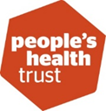Community Projects
This year has seen a mixture of grant support being secured to assist people and communities. Let’s Get Together project has been working in the South Tyne area for the last two years. This project, funded by the People’s Health Trust, has enhanced rural services through working with villages/hamlets and very remote residents. Over 600 people have benefitted from this project through participation in events and activities which have included adult education, complementary health, arts and culture. We are grateful to Peoples Health Trust for providing us with a further two years funding to support these vital services as we now see local people providing services for themselves through independent models of service funding and delivery
Back of Beyond Business Services

We have secured one of only a dozen grants nationally to pay for business start-up and support in remote rural areas of the county. Thanks to the Princes Countryside Fund we are expanding our pilot scheme from last year to take enterprise start up across most of the rural areas west/north of the county. This project aims to work with residents living in one of England's most remote areas, in the foothills of the high North Pennine range in west Northumberland. There is a serious lack of public transport in these rural communities, which has a detrimental impact on the available employment opportunities, particularly for young people, parents of young children and those with no access to transport. This project aims to engage with these groups and provide inspiration to develop local solutions through enterprise. An outcome will be a sustainable business and community support organisation based within the area. We will work to identify potential business ideas, provide mentoring and support to develop a business plan, set up micro business, cooperatives and farm diversification schemes, generating income, business to business support and ultimately alternative forms of employment. We will provide an ongoing 'brokerage and factoring' service to continue to support rural businesses through in-house support, by negotiating to bring mainstream business support into the area when appropriate (e.g. Northumberland Business Services Ltd), offering bespoke training and through supporting a network of businesses to encourage business to business trade, keeping income generation within the area as much as possible and reducing economic leakage. Self-employment provides opportunities for people to continue to live in the communities they were born into; This project aims to sustain rural communities and drive economic vibrancy, as well contribute to improving the viability of family farm businesses.

A look at our Community projects
We are pleased to report an increased interest from funders in our Rural Community Economic Regeneration Work with the continuation of our Awards for All project and new work springing from this activity Awards for All provided funding for Let’s Get Together Too.
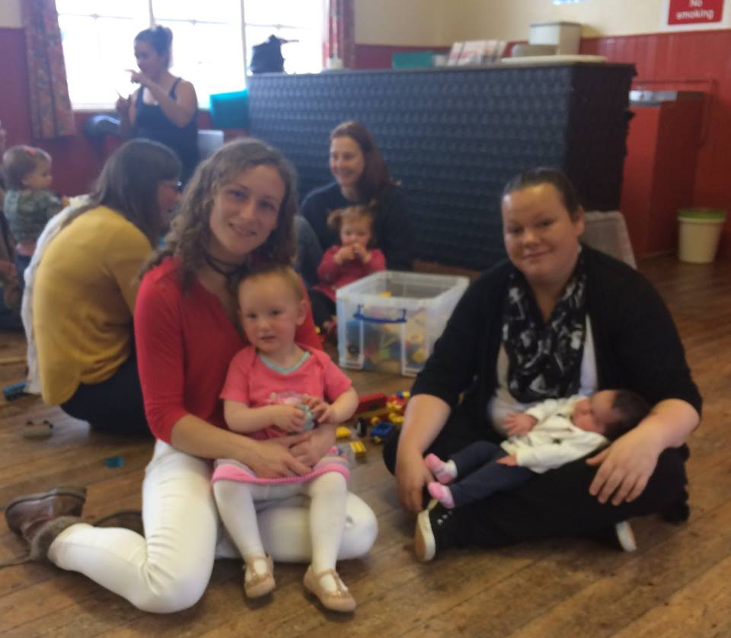This project was based in the North Tyne Valley, particularly the communities of Acomb, New
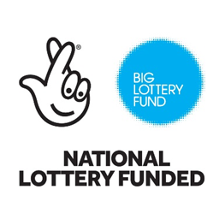brough, Wark, Bellingham and Kielder. NCDC is working in partner
with local communities and organisations to provide ser-
vices and opportunities for residents. The villages identi-
fied local priorities, through leafleting and surveys working
with NCDC, devising ways to improve service provision.

For example, Action for Acomb identified that for mums there
was a need to provide a service which enables mums to come together socially with their babies and toddlers for peer support. A locally based microbusiness provided Singing Babies and Squeaky Feet sessions in the village hall.
Our work in rural areas continues to be a priority although securing funding is difficult due to the “normal” indices of poverty being demonstrated on a different demographic to the urban model.

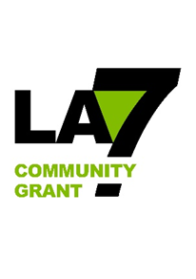NCDC has secured grant from Comic Relief through Tyne and Wear and Northumberland Community Foundation to add value to Let’s Get Together Too. This money recruited and supported new volunteers who are able to Befriend isolated residents and give them confidence to attend social and learning activities.
People looking for assistance to get into employment or self-employment have been helped by NCDC through three projects. Northumberland Access to Training is working with rural residents to improve their employability skills and confidence. This includes achieving Entry Level 3 Award in Skills for Employment, Training and Personal Development. This is an ESF project through LA7, managed by Gateshead Council.
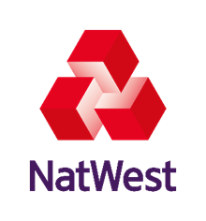Back of Beyond Businesses (Formally Rural Business Support) piloted work with20 people to explore self-employment. This programme was supported by the Skills and Opportunities Fund and provided workshops and mentoring. NCDC is building a rural business support network with backing from Northumberland Business Services Ltd and Social Enterprise Northumberland.
8 people have expressed an interest in continued assistance, and are now included in BOBBS, information events in conjunction with Young Farmers groups to raise awareness of NCDC’s support for rural enterprise
This year saw the end of our funding from Good Things Foundation. Dozens of residents have benefitted from the support of our digital champions. However, they now want to make progress and the funding no longer appears to be appropriate to meet residents need so we are seeking funding elsewhere together with offering digital skills through BOBBS

