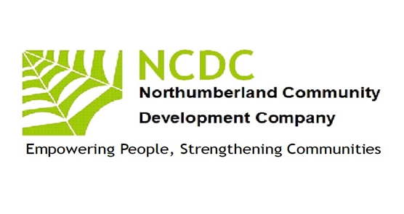
Empowering People
Strengthening
Communities
Empowering People
Strengthening
Communities
Annual Report 2018 –2019

Chairman’s report
This year has seen NCDC continue our redevelopment as we managed several complementary projects for which we raised funds from a number of sources.
I would like to thank everyone who has helped NCDC through this year of transition our staff team have delivered magnificent results. The team has recently expanded to deliver these projects with the addition of Maureen Lawrie, Jill Eastlake & Louise Northwood. To continue to deliver quality accredited learning, NCDC is working with a pool of tutors, assessors and internal verifiers, headed by Janet Cresswell and Maureen Lawrie
NCDC continues to work with volunteers, especially as Digital Champions, to enhance services. NCDC is grateful for their contributions of time, skills and expertise and to my colleagues on the board who have increased their commitment to steer the organisation forward.
I would also thank our funders who include Peoples Health Trust, Princes Countryside Fund, The Good Things Foundation, Awards 4 All, NatWest Skills and Opportunities Fund, and Gateshead Council (ESF). Our Board now has a realistic five-year plan though which we have consolidated and will now grow our organisation. We are focusing on our existing strengths in Inclusion, Learning, Networking and Economic Enterprise. The majority of our work this year has been in the sparse rural areas of the county replacing services and activities stripped out through centralisation of resources by public sector funders working with local people to develop skills and capacity to run sustainable programmes of learning.Wellbeing.Health and leisure. If you would like to find out more about working with NCDC, please contact me. John McGough, Chair. 07885303166

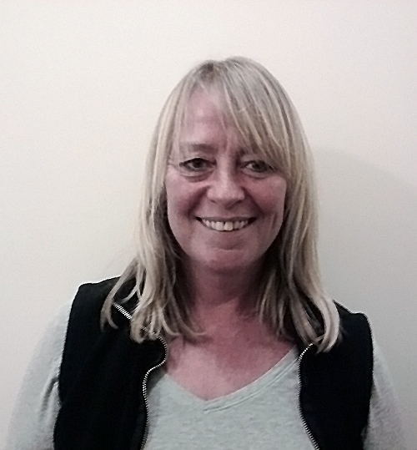
Pat Barber
John McGough
Cath Stocks
Jim Robertson
Our Work 2018-2019
Inclusion
NCDC continues to be a recognised UK Online Centre offering IT support to individuals across the county to increase their access to IT skills. Gordon Stewart has continued his support of our digital agenda/needs assisting us to improve our IT skills and confidence through working with Pat Barber in relaunching our webpage and social media profiles
NCDC is a champion of rural services activity alongside Community Action Northumberland. We are focused on working in the very sparsely populated areas, which often have little or no public transport, virtually no adult learning, debt advisory services more than 20 miles away, and with a population which is becoming isolated and somewhat destitute through the lack of public service provision. We are working with local people to assist them provide services they want within easy travel /time.
Networking
Whilst locally we are developing enterprise and community networks NCDC is also involved countywide in the VCS networks through which major policy can be seen to emerge. We are elected on the VCS Assembly Executive as representatives for the west of the county and on VONNE’S VCSE focus group which through its relationship with the NELEP informs and works alongside public sector partners in designing and delivering services for the counties/regions residents. We have also assisted Northumberland Care in the design of some of their new Locality posts.
Learning
NCDC is a registered training organisation for NOCN (previously the National Open College Network) and One Awards and continues to offer training and support to individuals in skills involved in developing communities. We worked with learners from remote areas in West Northumberland to offer an Entry Level 3 Award in Skills for Employment, Training and Personal Development. We’ve also seen a number of local residents achieve First Aid, Food Hygiene and Health and Safety Qualifications thus ensuring their community activities are safer
Economic Enterprise
Working with local residents we have undertaken an annual research project through which we have identified needs, skills, local business ideas and generated a culture of organisations working to generate their own sustainable wealth rather than be completely reliant on grant funding. With two of our larger community projects we have seen village hall committees raising thousands of pounds to support their activities with viable activities together with local fundraising. While on a micro level we have assisted activity leaders to become legitimate business operators charging for their activities at such levels to produce a living wage. We have offered specific business starter workshops, mentoring, marketing expertise to assist new rural business to thrive. This is now developing into a local marketplace for business to business trading thus reducing economic leakage of wealth, With support from Princes Countryside Fund we have supported 56 new rural businesses to start up, offered ongoing skills training and linked with local young farmers, agricultural show committees, Women’s Institutes to generate a culture of community enterprise .NCDC has been a visible force in raising a campaign banner for rural community.
A look at our Community projects

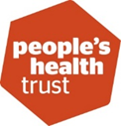
The project has continued to go from strength to strength and is now seen as a valuable resource in parts of the South Tynedale area. Awareness of the project has grown with 106 followers on Facebook, 150 on the Mailchimp list and database and more being added all the time. Some Facebook posts are attracting over 2000 views. People moving to the area are regularly referred to LGT for information on what’s happening. Old connections have been strengthened and new ones made with partner organisations including Healthwatch Northumberland, Talking Matters, Age UK, South Tynedale Sustainability, Brampton Community Trust, Haltwhistle Partnership, Carers Northumberland, Cancer Carers Support and more.
The project is also attracting interest from further afield with potential events linking different parts of the country as well as the county and organisations within it. We’ve been pleased to support Redburn Rangers for a second year and the Zig Zag project in Haltwhistle.

Back of Beyond Business (Formally Rural Business Support) Skills project, has help us to provide training to help develop skills with people who wanted to start their own business in rural Northumberland. We set up individual development programme’s which included action plans, workshops, accredited and non-accredited training. The training courses were well received.

This year saw the end of our funding from Good Things Foundation. Dozens of residents have benefitted from the support of our digital champions. However, they now want to make progress and the funding no longer appears to be appropriate to meet residents need so we are seeking funding elsewhere together with offering digital skills through BOBBS.

Thanks to the Princes Countryside Fund we are expanding our pilot scheme from last year to take enterprise start up across most of the rural areas west/north of the county. This project aims to work with residents living in one of England's most remote areas, in the foothills of the high North Pennine range in west Northumberland. There is a serious lack of public transport in these rural communities, which has a detrimental impact on the available employment opportunities, particularly for young people, parents of young children and those with no access to transport. This project aims to engage with these groups and provide inspiration to develop local solutions through enterprise. An outcome will be a sustainable business and community support organisation based within the area. We will work to identify potential business ideas, provide mentoring and support to develop a business plan, set up micro business, cooperatives and farm diversification schemes, generating income, business to business support and ultimately alternative forms of employment. We will provide an ongoing 'brokerage and factoring' service to continue to support rural businesses through in-house support, by negotiating to bring mainstream business support into the area when appropriate (e.g. Northumberland Business Services Ltd), offering bespoke training and through supporting a network of businesses to encourage business to business trade, keeping income generation within the area as much as possible and reducing economic leakage. Self-employment provides opportunities for people to continue to live in the communities they were born into; This project aims to sustain rural communities and drive economic vibrancy, as well contribute to improving the viability of family farm businesses.

