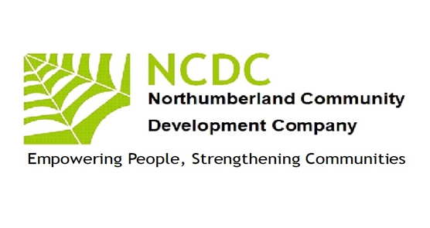
Empowering People
Strengthening
Communities
Empowering People
Strengthening
Communities
Annual Report 2019 –2020

Chairman’s report
This year has seen NCDC manage several complementary projects for which we raised funds from a number of sources.
I would like to thank everyone who has helped NCDC through this year of transition our staff team have delivered magnificent results. The team of Maureen Lawrie, Jill Eastlake, Janet Cresswell, Louise Northwood. We will continue to deliver quality accredited learning, working with a pool of tutors, assessors and internal verifiers, headed by Janet Cresswell
NCDC continues to work with volunteers, especially as Community Champions, to enhance services. NCDC is grateful for their contributions of time, skills and expertise and to my colleagues on the board who have increased their commitment to steer the organisation forward.
I would also thank our funders who include Peoples Health Trust, Princes Countryside Fund, Awards 4 All, NatWest Skills and Opportunities Fund, and Gateshead Council (ESF). Our Board, with a five year strategic plan is now growing our organisation. We are focusing on our existing strengths in Inclusion, Learning, Networking and Economic Enterprise. The majority of our work this year has been in the sparse rural areas of the county replacing services and activities stripped out through centralisation of resources by public sector funders working with local people to develop skills and capacity to run sustainable programmes of learning.Wellbeing.Health and leisure. OF course the recent lockdown through COVID 19 is going to generate lots of change but NCDC is prepared to accept the challenges. If you would like to find out more about working with NCDC, please contact me. John McGough, Chair. 07885303166

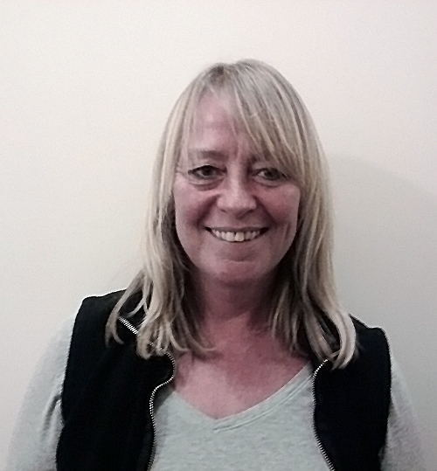
Pat Barber
John McGough
Cath Stocks
Jim Robertson

Our Work 2019-2020
Inclusion
NCDC continues to be a recognised UK Online Centre offering IT support to individuals across the county to increase their access to IT skills.
NCDC is a champion of rural services activity alongside Community Action Northumberland. We are focused on working in the very sparsely populated areas, which often have little or no public transport, virtually no adult learning, debt advisory services more than 20 miles away, and with a population which is becoming isolated and somewhat destitute through the lack of public service provision. We are working with local people to assist them provide services they want within easy travel /time.
Networking
Whilst locally we are developing enterprise and community networks NCDC is also involved countywide in the VCS networks through which major policy can be seen to emerge. We are elected on the VCS Assembly Executive as representatives for the west of the county and on VONNE’S VCSE focus group which through its relationship with the NELEP informs and works alongside public sector partners in designing and delivering services for the counties/regions residents. We have also assisted Northumberland Care in their new Locality posts by meeting up and providing detailed local information.
Learning
NCDC is a registered training organisation for NOCN (previously the National Open College Network) and One Awards and continues to offer training and support to individuals in skills involved in developing communities. We worked with learners from remote areas in West Northumberland to offer an Entry Level 3 Award in Skills for Employment, Training and Personal Development. We’ve also seen a number of local residents achieve First Aid, Food Hygiene and Health and Safety Qualifications thus ensuring their community activities are safer
Economic Enterprise
Working with local residents we have undertaken an annual research project through which we have identified needs, skills, local business ideas and generated a culture of organisations working to generate their own sustainable wealth rather than be completely reliant on grant funding. With two of our larger community projects we have seen village hall committees raising thousands of pounds to support their activities with viable activities together with local fundraising. While on a micro level we have assisted activity leaders to become legitimate business operators charging for their activities at such levels to produce a living wage. We have offered specific business starter workshops, mentoring, marketing expertise to assist new rural business to thrive. This is now developing into a local marketplace for business to business trading thus reducing economic leakage of wealth, With support from Princes Countryside Fund we have supported 56 new rural businesses to start up, offered ongoing skills training and linked with local young farmers, agricultural show committees, Women’s Institutes to generate a culture of community enterprise .NCDC has been a visible force in raising a campaign banner for rural community.
A look at our Community projects

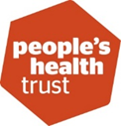
The project has continued to go from strength to strength and is now seen as a valuable resource in parts of the South Tynedale area. Awareness of the project has grown massively Some Facebook posts are attracting over 2000 views. People moving to the area are regularly referred to LGT for information on what’s happening. Old connections have been strengthened and new ones made with partner organisations including Healthwatch Northumberland, Talking Matters, Age UK, South Tynedale Sustainability, Brampton Community Trust, Haltwhistle Partnership, Carers Northumberland, Cancer Carers Support and more. Although the funding for this work is over we have managed to continue its activities and secured new funds for 2020-2021

Back of Beyond Business (Formally Rural Business Support) Skills project, has help us to provide training to help develop skills with people who wanted to start their own business in rural Northumberland. We set up individual development programme’s which included action plans, workshops, accredited and non-accredited training. The training courses were well received, and without funding we have managed to continue the support network

Thanks to the Princes Countryside Fund we expanded our pilot scheme from last year to take enterprise start up across most of the rural areas west/north of the county. This project worked with residents living in one of England's most remote areas, in the foothills of the high North Pennine range in west Northumberland. There is a serious lack of public transport in these rural communities, which has a detrimental impact on the available employment opportunities, particularly for young people, parents of young children and those with no access to transport. We engaged with these groups and provided inspiration to develop local solutions through enterprise. Outcomes will include a sustainable business and community support organisation based within the area. We worked to identify potential business ideas, provide mentoring and support to develop a business plan, set up micro business, cooperatives and farm diversification schemes, generating income, business to business support and ultimately alternative forms of employment. We provided an ongoing 'brokerage and factoring' service to continue to support rural businesses through in-house support, by negotiating to bring mainstream business support into the area when appropriate (e.g. Northumberland Business Services Ltd), offering bespoke training and through supporting a network of businesses to encourage business to business trade, keeping income generation within the area as much as possible and reducing economic leakage. Self-employment provides opportunities for people to continue to live in the communities they were born into; This project although over will continue to sustain rural communities and drive economic vibrancy, as well contribute to improving the viability of family farm businesses.

