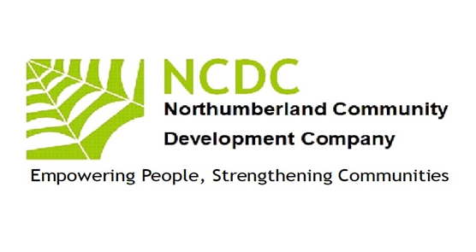
Empowering People
Strengthening
Communities
Empowering People
Strengthening
Communities
Annual Report 2021 –2022

Chairman’s report
Due to the sanctions determined by the COVID Pandemic NCDCs activities have been severely curtailed in terms of face-to-face work with community groups
The directors however have continued to maintain our profile with both Public Sector and VCS through online sessions, news bulletins and the maintenance of our on-line presence
(thanks to Pat -a reliable volunteer)
The groups we have maintained regular contact with are listed below with Jim constantly promoting our passion for rural work -when it is often overlooked by urban focussed groups
VCS Health Network [Monthly]
VCS Assembly (NCVA) and Executive
Health Network Conference. [Morpeth]
NCC -VCS link groups
Rural Design Centre. {Participated in Monthly Cafe Meeting}
National Design and Rural Design Centre All Day Workshop Ellington Nr Alnwick
Contact with Faith Community Development Initiatives. Introduction event of New FIC Worker in Wooler. [5 Year Appointment] and Cof E, URC and Catholic Churches Trust, Chapels Trust on-going projects
Community Local Economic CLES}. Community Wealth Building Short Course.
Local Village Hall and Community Hub groups in Featherstone and Wylam
Plans for 2022-2023 include looking to develop through working very closely with other rural focussed organisations and reviewing our training offers. Refreshing Lets Get Together-our village-based activity programme
As with every other VCS organisation we are always keen to talk about our work and seek to involve new directors
If you would like to find out more about working with NCDC, please contact me. John McGough, Chair. 07885303166
Pat Barber
John McGough

Jim Robertson

Our Work 2020-2021
Inclusion
NCDC continues to be a recognised UK Online Centre offering IT support to individuals across the county to increase their access to IT skills.
NCDC is a champion of rural services activity alongside Community Action Northumberland. We are focused on working in the very sparsely populated areas, which often have little or no public transport, virtually no adult learning, debt advisory services more than twenty miles away, and with a population which is becoming isolated and destitute through the lack of public service provision. We are collaborating with local people to assist them provide services they want within easy travel /time.
Networking
Whilst locally we are developing enterprise and community networks NCDC is also involved countywide in the VCS networks through which major policy can be seen to emerge. We are elected on the VCS Assembly Executive as representatives for the west of the county and on VONNE’S VCSE focus group which through its relationship with the NELEP informs and works alongside public sector partners in designing and delivering services for the counties/regions residents. We have also assisted Northumberland Care/NCC in their new Locality posts by meeting up and providing detailed local information. Our All-Aboard project brought the tiny hamlets and villages in the outer west together exploring Local History and produced a beautiful poster which has been distributed to residents
Learning
NCDC is a registered training organisation for NOCN (previously the National Open College Network) and One Awards and continues to offer training and support to individuals in skills involved in developing communities. We worked with learners from remote areas in West Northumberland to offer an Award in Community Development. This was successful with most gaining a qualification.
On a diverse cultural thread two of our team supported and curated an online art exhibition with over a dozen local artists relating to our rural environment. This is still active as a U-Tube link as due to COVID we have yet been unable to take it on tour in local community venues. The link is https://www.youtube.com/watch?v=68o_X8PeieM
Economic Enterprise
Collaborating with local residents we have undertaken two research projects through which we have identified needs, skills, local business ideas and generated a culture of organisations working to generate their own sustainable wealth rather than be completely reliant on grant funding. We have reported locally on the Skills needs in the hospitality sector and in rural/farming businesses We have offered specific business support, mentoring, marketing expertise to assist new rural business to thrive. This is now developing into a local marketplace for business-to-business trading thus reducing economic leakage of wealth. NCDC has been a visible force in raising a campaign banner for rural community.

Statement
2021-22 AGM meeting for Northumberland Community Development Company
Took take place on Friday 9th December. It stared at 1.30pm and was ended at 3.45pm

The venue was held at The Hub at Halbankgate, and Light refreshments were made
available-thanks to The Hub.
……………………………………………………………………………………………………………………….

On the agenda:
- Acceptance of Accounts:
The Accounts were presented and accepted; John will ask Pat to update our website with most recent accounts.
- Proposals for changes in Mem and Arts Clauses:
It was agreed that these can be drafted and presented to an EGM in the New Year. Legal support has been engaged with John Lyon of Cartmell Shepherd Solicitors for checking final draft wording before its agreed and sent to Companies House.
- Nominations of Directors:
This would be put forward as an agenda item for the EGM.

- A discussion on the Covid Situation:
The meeting was informed that due to the sanctions determined by Covid Pandemic, NCDC activities have been severely affected.
- A discussion on potential merger with another company:
Two other small companies with interests in rural community work have expressed a wish to enter discussions regarding mergers. It was agreed that our current directors take on these discussions and report back to a future meeting.

John McGough
Chair NCDC

Attendees: John McGough, Jim Robertson, Patrick Barber
Margaret Watts, David Bell, Peter Knight

