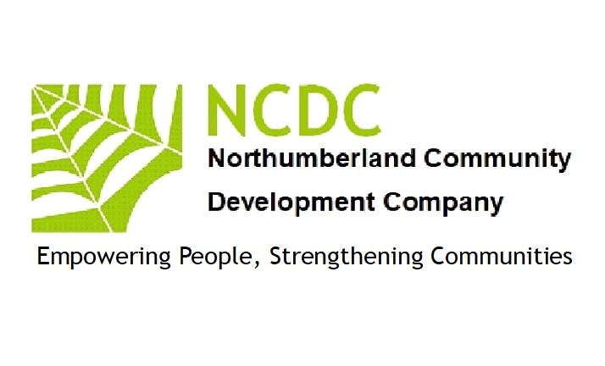
ANTI-SLAVERY POLICY

Modern slavery is a crime and a violation of fundamental human rights. It takes various forms,
such as slavery, servitude, forced and compulsory labour and human trafficking, all of which
have in common the deprivation of a person’s liberty by another in order to exploit them for
personal or commercial gain.

The NCDC has a zero-tolerance approach to modern slavery, and we are committed to acting
ethical y and with integrity in all our business dealings and relationships and to implementing and
enforcing effective systems and controls to ensure modern slavery is not taking place anywhere
in our own business.

We are also committed to ensuring there is transparency in our own business and in our
approach to tackling modern slavery throughout our supply chains, consistent with our disclosure
obligations under the Modern Slavery Act 2015.

We expect the same high standards from all of our contractors and other business
partners, and as part of our contracting processes, in the coming year we will include specific
prohibitions against the use of forced, compulsory or trafficked labour, or anyone held in slavery
or servitude, whether adults or children, and we expect that our contractors will hold their own
suppliers to the same high standards.

This policy applies to all persons working for us or on our behalf in any capacity, including
employees at all levels, directors, officers, agency workers, seconded workers, volunteers,
interns, agents, contractors, external consultants, third-party representatives and business
partners.

This policy does not form part of any employee’s contract of employment and we may amend it
at any time.

Responsibility for the policy

The NCDC has overall responsibility for ensuring this policy complies with our legal and
ethical obligations, and that all those under our control comply with it.

The NCDC has primary and day-to-day responsibility for implementing this policy, monitoring
its use and effectiveness, dealing with any queries about it, and auditing internal control systems
and procedures to ensure they are effective in countering modern slavery.

Management at all levels are responsible for ensuring those reporting to them understand and
comply with this policy and are given adequate and regular training on it and the issue of modern
slavery in supply chains.

You are invited to comment on this policy and suggest ways in which it might be improved.
Comments, suggestions and queries are encouraged and should be addressed to the Managing
Director. JohnM@ncdc.org.uk
Compliance with the policy

You must ensure that you read, understand and comply with this policy.

The prevention, detection and reporting of modern slavery in any part of our business
is the responsibility of all those working for us or under our control.
You are required to avoid any activity that might lead to, or suggest, a breach of this policy.
You must notify your line manager or a company Director as soon as possible if you believe or
suspect that a conflict with this policy has occurred or may occur in the future.

You are encouraged to raise concerns about any issue or suspicion of modern slavery in any
parts of our business at earliest possible stage.
If you believe or suspect a breach of this policy has occurred or that it may occur, you must notify
your line manager or company Director or report it in accordance with our Whistleblowing Policy
as soon as possible.

You should note that where appropriate, and with the welfare and safety of local workers as a
priority, we will give support and guidance to our suppliers to help them address coercive,
abusive and exploitative work practices in their own business.

If you are unsure about whether a particular act, the treatment of workers more generally, or their
working conditions within any tier of our supply chains constitutes any of the various forms of
modern slavery, raise it with your line manager or company Director.

We aim to encourage openness and will support anyone who raises genuine concerns in good
faith under this policy, even if they turn out to be mistaken. We are committed to ensuring no one
suffers any detrimental treatment as a result of reporting in good faith their suspicion that modern
slavery of whatever form is or may be taking place in any part of our own business or in any of
our supply chains.

Detrimental treatment includes dismissal, disciplinary action, threats or other unfavourable
treatment connected with raising a concern.

If you believe that you have suffered any such treatment, you should inform your line manager
immediately. If the matter is not remedied, and you are an employee, you should raise it formally
using our Grievance Procedure, which can be found in the current employee handbook.

This Modern (Anti) Slavery Policy and Statement is intended for businesses in all countries,
especially the United Kingdom.

Communication & awareness of this policy

Training on this policy, and on the risk our business faces from modern slavery in its supply
chains, forms part of the induction process for all individuals who work for us, and updates will be
provided using established methods of communication between the business and you.
Our zero-tolerance approach to modern slavery must be communicated to all suppliers,
contractors and business partners at the outset of our business relationship with them and
reinforced as appropriate thereafter.

Breaches of this policy

Any employee who breaches this policy will face disciplinary action, which could result in
dismissal for misconduct or gross misconduct. We may terminate our relationship with other
individuals and organisations working on our behalf if they breach this policy.

The above policy was reviewed and updated by the Board of Directors (NCDC)
Signed 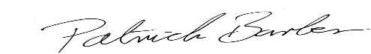 September 12th 2023
Patrick Barber (Director NCDC)

