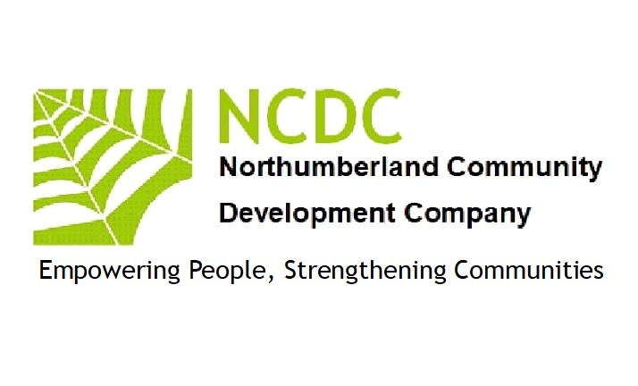
DBS Policy 2023
Introduction:
1 The safety of children and young people is paramount, and Northumberland Community Development Company is committed to implementing the Disclosure and Barring (DBS) procedures and arrangements. We will comply with the DBS Code of Practice and National Care Standards guidance regarding the correct handling, use, storage, retention and disposal of Certificates.

2 The DBS (formerly the CRB Agency) was set up by the Home Office to improve access to criminal record checks for employment related purposes and to help organisations make safer recruitment decisions; this applies to staff with access to children under 18 years of age, vulnerable adults or other positions of trust that fall within the Rehabilitation of Offenders Act 1974. The DBS and the Independent Safeguarding Authority (ISA) both became part of the Disclosure and Barring Service (DBS) in December 2012.

Policy:

1: All persons work with valuable adults/children must have a DBS certificate. If the person does not, then NCDC may apply for one, but no appointment can be taken up until it has been received and reviewed.

2: NCDC will use .GOV or an out side agency to obtain a certificates.

3:The board will review the certificates if non disclosures are found. Their decision is Final.

This policy applies to the appointment of all employees, paid and unpaid, including Directors volunteers and Contractors. It is designed to assist in ensuring that all persons working at Northumberland Community Development Company are trustworthy and reliable and are not subject to any offences which may put us or our clients at risk.

Enhanced Certificates:
Northumberland Community Development Company may require DBS Certificates at an Enhanced level. This involves an extra level of check with local police force records in addition to checks with the Police National Computer and the government department lists held by the Department for Children, Schools and Families and Department of Health, where appropriate. The government’s safer recruitment initiative stipulates that all staff in an educational establishment must have an enhanced Certificate.
The above policy was reviewed and up dated by the Board of Directors(NCDC)
Singed 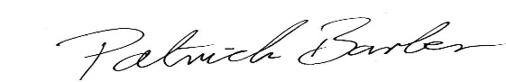 September 12th 2023
Patrick Barber(Director NCDC)

