Data Protection Policy 2023
What information do we collect about you?
We collect the information you give us when you participate in our activities.
You can update your information at any times by contacting Patrick Barber (Data Manager at the email listed below.
The data will be stored on computers belonging to people employed or commissioned by NCDC.

How will we use the information about you?
We will use the information to provide a service to you and, if you agree, to contact you with emails containing information we believe to be of interest or value to you.
The information will not be shared with third parties
NCDC will use statistical data (Not able to identify individuals) to better understand how people are using our services and apply for funding to meet future needs.

Cookies
Cookies are text files placed on your computer when you visit our website to collect standard internet log information and visitor behaviour information. This information is used to track visitor use of the website and to compile statistical reports on website activity. We use third party services Google Analytics and Privy.
For further information visit www.aboutcookies.org or www.allaboutcookies.org.uk

Changes to Privacy Policy
We keep our privacy policy under review and will place any updates on our web site.
Please contact us if you have any question about our privacy policy or information, we hold about you.
John McGough (Data Manager) JohnM@ncdc.org.uk / 07885303166
The above policy was reviewed and updated by the Board of Directors (NCDC)
Signed 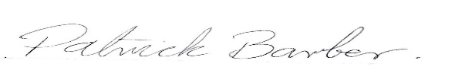September 12th 2023
Patrick Barber (Director NCDC)

