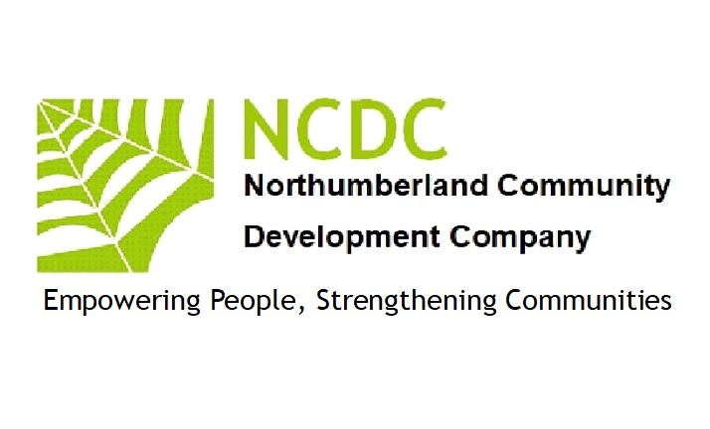
Environment Policy 2023

Values
NCDC is committed to protect and sustain the environment in all its activities. It is signed up to the national occupation standards on sustainability in community development.

Legal obligations
NCDC will comply with Duty of Care regulations laid out in legislation and will regularly review its practices with reference to legal obligations seeking advice from current sources (such as www.brookes.ac.uk/eie/law)

Waste management
All waste will be sorted and re-cycled wherever possible. Cartridges will be returned, and non-recyclable goods will be kept to a minimum and disposed of responsibly. We will continue to seek advice from colleagues with specialist knowledge and participate in shared schemes.

Purchasing
NCDC is committed to ensuring that 75% of its paper is re-cycled, and that electronic equipment will be re-cycled for re-use or community use.
NCDC will ensure that all purchases are made from companies that promote good practice in environmental matters.

Carbon footprint
NCDC will acquire software to enable a regular check on its carbon footprint and will revise practices regularly to reduce its impact. NCDC will share resources such as offices, electronic equipment, and white goods wherever possible.

Training
NCDC staff will take part in training related to good practice in sustainable community development on at least an annual basis and one member of staff who will be responsible for overseeing environmental matters will be provided with full training on compliance and good practice.

The above policy was reviewed and updated by the Board of Directors (NCDC)
Signed 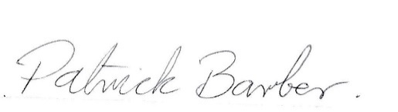September 12th 2023

Patrick Barber (Director NCDC)

