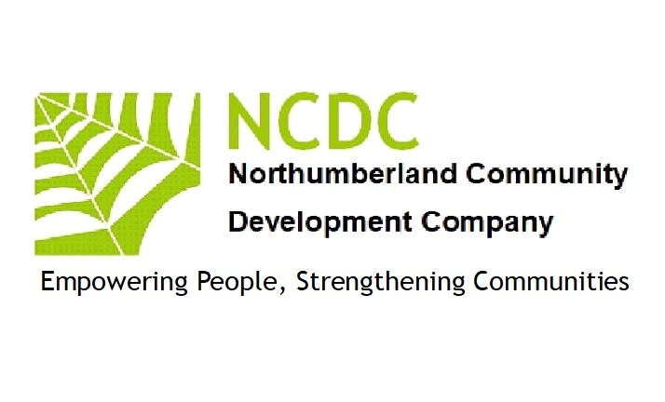

Equal Opportunities Policy & Plan 2023

EQUAL OPPORTUNITIES POLICY OBJECTIVES

OBJECTIVE ONE

Area of Operations: Recruitment, Selection and Employment of paid staff

Northumberland Community Development Company (NCDC) will try to ensure that all its recruitment and selection procedures - advertising, application forms, short-listing, interviewing, and final selection are carried out in a way that eliminates discriminatory bias. We will actively encourage staff development and training which enhances awareness of discrimination and inequality. We will positively encourage applications from disadvantaged and minority groups and endeavour within the limits of our financial resources to offer training and development opportunities to offset initial disadvantages where appropriate.

Where we employ people directly, our conditions of service and standard employment procedures will reflect our aim to treat all our staff as fairly and as generously as possible.
We will apply the same standards to any tendering processes, which are the preferred means of creating opportunities for paid work within the Network, in order to encourage entrepreneurial activity and to contribute to the resources of member organisations where their staff take part in paid project work on behalf of NCDC.

OBJECTIVE TWO

Area of Operations: recruitment, training, and support of volunteers

NCDC will try to eliminate discriminatory bias when advertising for and interviewing volunteers. We will work towards making any volunteer training programmes as accessible as possible to people who have English as their second language or who experience hearing or sight impairment. We will positively encourage all sectors of society to access our volunteering opportunities. Volunteer training programmes will feature awareness raising about equality issues.

OBJECTIVE THREE

Area of Operations: publicity, publications, and public image

NCDC’s publicity, promotional materials and advertising will endeavour to avoid discrimination and stereotypical images and expressions. We will actively screen our literature for such images and will seek to make NCDC known and available to all sections of the community. A copy of this Equal Opportunities Policy will accompany our major funding applications.

OBJECTIVE FOUR

Area of Operations: Learning and Support

NCDC will not refuse its services to anyone on discriminatory grounds but will set out to offer appropriate learning support for each individual that seeks it, as far as is possible within the constraints of availability of workers, volunteers and adequate resources to train and support them. Each individual will be treated equally in terms of:
Respect for their values, their lifestyle, and their culture; confidentiality; honest explanations about the learning support available; equal access to assessor; equal access to learning for those who work unsocial hours; recognition and supply of any special assessment requirements, including alternative recording methods; language support; access to records about themselves; and a code of practice for peer relationships.

NCDC’s Assessment Centre for NVQs is subject to a full access and fair assessment policy and practice that is understood and complied with by candidates and assessors. Candidates and assessors will be invited to fill in an equal opportunity monitoring form to help in the evaluation of the effectiveness of access policies.

OBJECTIVE FIVE

Area of Operations: Management by the Board of Directors

NCDC will try to ensure that its Board reflects as many sections of the Network it supports as possible and will actively seek representation from minority groups. Board members will be invited for their skills and experience, their commitment to the Principles of Community Development, and their network of useful contacts. No one will be excluded from membership of the Board on discriminatory grounds.

Equal Opportunities Legislation

NCDC recognises the following legislation:
- The Disabled Employment Acts 1944 and 1958 and the Disability Discrimination Act 2010
- The Children Act 2004
- Sex Discrimination and Equality Act 2010
- Race Relations Act 1976, Race Relations Amendment Act 2000
- New Directives on sexual orientation and religion/faith discrimination
- The Employment Equality (Age) Regulations 2006
- Human Rights Act 1998
We will endeavour to act with the spirit of these and any subsequent legislation, over and beyond our legal obligations as a small not-for-profit company.

Equal Opportunities Statement

Discrimination is one of many factors contributing to social isolation and stress.
NCDC is opposed to discrimination and exists to help alleviate its effects.

Our aim is to be available, relevant, and inclusive, throughout the community.
Our work benefits from including a diverse group of people, and we endeavour to meet practical challenges raised by disabilities, language problems and other potential barriers.
Our commitment is to redress discrimination on the grounds of gender, social class, race, religion, culture, sexual orientation, disability, and age, both in our own practice and in society.

Action Plan 2023-2024

NCDC, will further develop its monitoring system to ensure targets are subject to meaningful review.

Equal opportunity targets will form part of the overall quality assurance programme of NCDC.

NCDC will organise an annual event on an aspect of equality and diversity; and will promote good practice in community development through taking up positions on relevant strategic bodies and projects.

NCDC will maintain active membership of diversity networks.

NCDC will continue to experiment with new models of recruitment and access to paid work that are in keeping with community development and equality and diversity principles and practice.

NCDC will highlight new legislation and equality activity through its website and other communications.

The NCDC website will aim to be disability-friendly and will invite feedback from web users with special requirements.

NCDC will work closely with public sector partners to promote a voice for excluded groups within decision-making in Northumberland.

NCDC will extend its reach by using local accessible community venues throughout the county.

The above policy was reviewed and updated by the Board of Directors (NCDC)

Signed 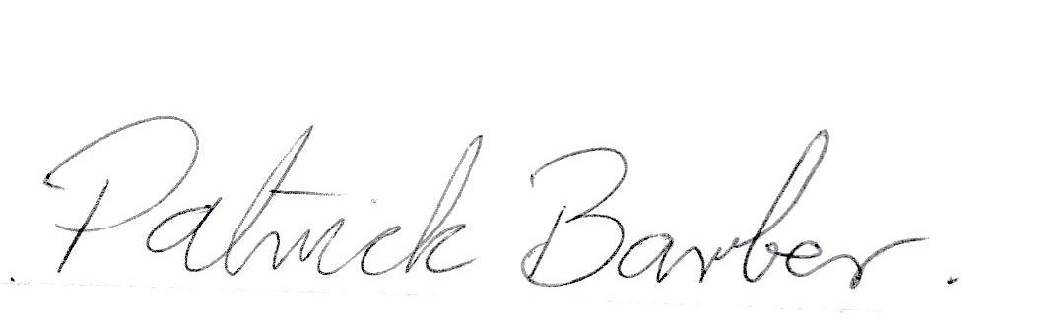September 12th 2023

Patrick Barber (Director NCDC)

