Ethics Policy 2023

It is the policy of NCDC that its employees and board members uphold the
highest standards of ethical and professional behaviour. To that end, these employees and board members shall dedicate themselves to carrying out the mission of this organization and shall.

- Hold paramount the safety, health, and welfare of the public in the performance of professional duties.

- Act in such a manner as to uphold and enhance personal and professional honour, integrity, and the dignity of the profession.

- Treat with respect and consideration all persons, regardless of race, religion, gender, sexual orientation, maternity, marital or family status, disability, age, or national origin.

- Engage in carrying out NCDC mission in a professional manner.

- Collaborate with and support other professionals in carrying out NCDC mission.

- Build professional reputations on the merit of services and refrain from competing unfairly with others.

- Recognize that the chief function of NCDC all times is to serve the
best interests of its constituency.

- Accept as a personal duty the responsibility to keep up to date on emerging issues and to conduct themselves with professional competence, fairness, impartiality, efficiency, and effectiveness.

- Respect the structure and responsibilities of the board of directors, provide them with facts and advice as a basis for their making policy decisions and uphold and implement policies adopted by the board of directors.

- Keep the community informed about issues affecting it.

- Conduct organizational and operational duties with positive leadership exemplified by open communication, creativity, dedication, and compassion.

- Exercise whatever discretionary authority they have under the law to carry out the mission of the organization.

- Serve with respect, concern, courtesy, and responsiveness in carrying out the
organization’s mission.

- Demonstrate the highest standards of personal integrity, truthfulness, honesty, and fortitude in all activities to inspire confidence and trust in such activities.

- Avoid any interest or activity that conflicts with the conduct of their official duties.

- Respect and protect privileged information to which they have access during their official duties.

- Strive for personal and professional excellence and encourage the professional developments of others.

The above policy was reviewed and updated by the Board of Directors (NCDC)

Signed 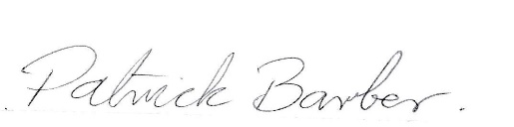September 12th 2023

Patrick Barber (Director NCDC)

