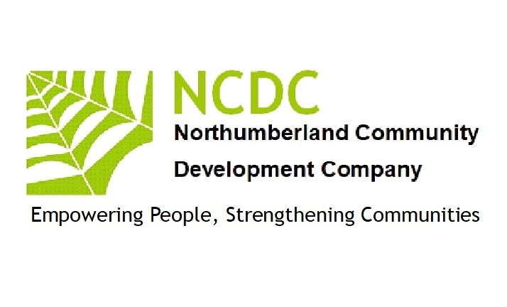
FRAUD POLICY 2023

BACKGROUND

This fraud policy is established to facilitate the development of controls which will aid in the detection and prevention of fraud against Northumberland Community Development Company. It is the intent of Northumberland Community Development Company to promote consistent organisational behaviour by providing guidelines and assigning responsibility for the development of controls and conduct of investigations. It complies with the requirements of the Thefts Act 1968 (NI 1969) & 1978 and the Fraud Act 2007

SCOPE OF POLICY

This policy applies to any fraud, or suspected fraud, involving employees as well as shareholders, consultants, vendors, contractors, outside agencies doing business with employees of such agencies, and/or any other parties with a business relationship with Northumberland Community Development Company (also called the Company).
Any investigative activity required will be conducted without regard to the suspected wrongdoer’s length of service, position/title, or relationship to the Company.

POLICY

The Data Manager (Patrick Barber) is responsible for the detection and prevention of fraud, misappropriations, and other inappropriate conduct. Fraud is defined as the intentional, false representation or concealment of a material fact for inducing another to act upon it to his or her injury. Each member of the management team will be familiar with the types of improprieties that might occur within his or her area of responsibility and be alert for any indication of irregularity.
Any fraud that is detected or suspected must be reported immediately to the Data Manager, who coordinates all investigations both internal and external.

ACTIONS CONSTITUTING FRAUD

The terms defalcation, misappropriation, and other fiscal wrongdoings refer to, but are not limited to:
• Any dishonest or fraudulent act
• Forgery or alteration of any document or account belonging to the Company
• Forgery or alteration of a cheque, bank draft, or any other financial document
• Misappropriation of funds, securities, supplies, or other assets
• Impropriety in the handling or reporting of money or financial transactions
• Profiteering because of insider knowledge of company activities
• Disclosing confidential and proprietary information to outside parties
• Disclosing to other persons securities activities engaged in or contemplated by the company
• Accepting or seeking anything of material value from contractor’s vendors or persons providing services/materials to the Company.
• Destruction, removal or inappropriate use of records, furniture, fixtures, and equipment; and/or
• Any similar or related inappropriate conduct

OTHER INAPPROPRIATE CONDUCT

Suspected improprieties concerning a person’s moral, ethical, or behavioural conduct, should be resolved by the most appropriate director of the company.
If there is any question as to whether an action constitutes fraud, contact the Data Manager for initial guidance.

INVESTIGATION RESPONSIBILITIES

The Data Manager has primary responsibility for the investigation of all suspected fraudulent acts as defined in the policy. If the investigation substantiates that fraudulent activities have occurred, then the Data Manager will issue reports to appropriate designated personnel and, if appropriate, to the Board of Directors.

Decisions to prosecute or refer the examination results to the appropriate law enforcement and/or regulatory agencies for independent investigation will be made in conjunction with legal advice and senior management, as will final decisions on disposition of the case.

CONFIDENTIALITY

The Directors treat all information received confidentially. Any person who suspects dishonest or fraudulent activity will notify one of the directors immediately and should not attempt to personally conduct investigations or interviews/interrogations related to any suspected fraudulent activity.

Investigation results will not be disclosed or discussed with anyone other than those who have a legitimate need to know. This is important to avoid damaging the reputations of persons suspected but subsequently found innocent of wrongful conduct and to protect the Company from potential civil liability.

AUTHORISATION FOR INVESTIGATING SUSPECTED FRAUD

Members of the Investigation Unit will have:
• Free and unrestricted access to all Company records and premises, whether owned or rented; AND
• The authority to examine, copy, and/or remove all or any portion of the contents of files, desks, cabinets, and other storage facilities on the premises without prior knowledge or consent of any individual who may use or have custody of any such items or facilities when it is within the scope of their investigation.

REPORTING PROCEDURES

Great care must be taken in the investigation of suspected improprieties or wrongdoings to avoid mistaken accusations or alerting suspected individuals that an investigation is under way.
A person who discovers or suspects fraudulent activity will contact the Data Manager immediately. The person or another complainant may remain anonymous. All inquiries concerning the activity under investigation from the suspected individual, his or her solicitor or representative, or any other inquirer should be directed to the Board of Directors. No information concerning the status of an investigation will be given out. The proper response to any inquiries is: “I am not at liberty to discuss this matter.”

Under no circumstances should any reference be made to “the allegation,” “the crime,” “the fraud,” “the forgery,” “the misappropriation,” or any other specific reference.

The reporting individual should be informed of the following:
• Do not contact the suspected individual in an effort to determine facts or demand restitution.
• Do not discuss the case, facts, suspicions, or allegations with anyone unless specifically asked to do so by the Data Manager.

The Board of directors will designate one of their number as a contact person in the eventuality that the Data Manager is the subject of the suspected improprieties. Other Board members will be available for further stage of any investigation including any appeal.

DISMISSAL

If an investigation results in a recommendation to dismiss an individual, the recommendation will be reviewed for approval by the designated representatives of the Company and if necessary. their solicitor before any such action is taken.

ADMINISTRATION

The Board of Directors is responsible for the administration, revision,
interpretation, and application of this policy. The policy will be reviewed
annually and revised as needed.

The above policy was reviewed and updated by the Board of Directors (NCDC)

Signed 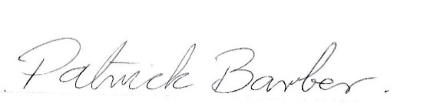September 12th 2023

Patrick Barber(Director/Data Manager)

