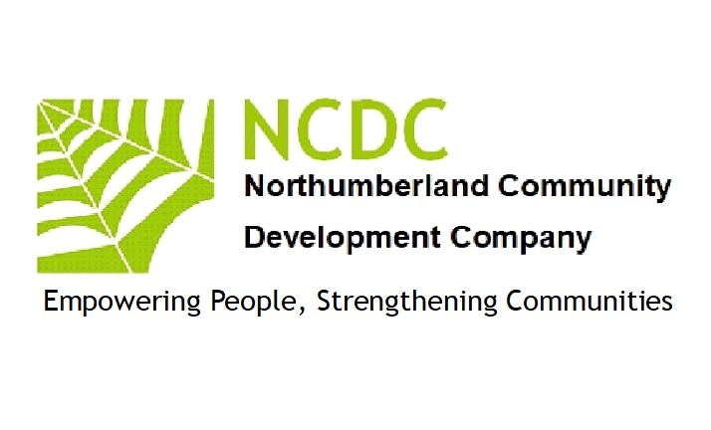
SAFEGUARDING VULNERABLE ADULTS POLICY 2023
for
Northumberland Community Development Company
1 Introduction
1 Northumberland Community Development Company is a not-for-profit organisation run by:
A board of directors
2 Northumberland Community Development Company is based at:
High Ramshaw. Coanwood
Haltwhistle
NE49 0PQ
3 Northumberland Community Development Company is managed by a management team (The Team). One of the management team has particular responsibility for safeguarding vulnerable adults.
4 The Team has adopted this safeguarding vulnerable adult policy and expects every adult working or helping at Northumberland Community Development Company to support it and comply with it. Consequently, this policy shall apply to all staff, managers, trustees, directors, volunteers, students or anyone working on behalf of Northumberland Community Development Company.
2 Purpose of the Policy
1 This policy is intended to protect vulnerable adults who receive any service from us, including those who are parents or carers who may receive services from us.
2 As an organisation we believe that no vulnerable adults should experience abuse or harm and are committed to the protection of vulnerable adults and this policy is intended to provide guidance and overarching principles to those who represent us as volunteers or staff, to guide our approach to vulnerable adults protection and safeguarding.

3 The risks to Vulnerable Young Adults
Nearly every vulnerable adult grows up in a safe and happy environment and it is important not to exaggerate or overestimate the dangers. Nevertheless, there are situations where vulnerable adults need protection including:
  - Sexual abuse
  - Grooming
  - Physical and emotional abuse and neglect
  - Domestic violence
  - Inappropriate supervision by staff or volunteers
  - Bullying, cyber bullying, acts of violence and aggression
  - Victimisation
  - Self-harm
  - Unsafe environments and activities
  - Crime
  - Exploitation
4 Universality of Protection
We recognise that:
  - the welfare of the vulnerable adult is paramount
  - all vulnerable adults regardless of race, gender, religious belief, disability, age, sexual orientation or identity have a right to equal protection from harm.
  - some adults are more vulnerable to harm as a result of their circumstances, prior experiences, communication needs or level of dependency.
  - working with vulnerable adults, their parents and/or guardians, carers or other agencies is essential to protecting their wellbeing.

5 Safeguarding Vulnerable Young Adults at events / activities
1 There are three kinds of events/activities:
1.1 those open to adults and children of all ages,
1.2 those for children accompanied by a 'parent',
1.3 those for unaccompanied children, which are sometimes run alongside other events/activities.
2 Both event and activities are to be defined broadly to include any occasions where Northumberland Community Development Company will be providing a service.
3 At events and activities for vulnerable adults who are accompanied by a parent or carer, must be supervised throughout the event by an adult only.

6 Disclosure and barring
1 Northumberland Community Development Company offers the following activities for vulnerable adults:
Activities in Community venues
Family Learning
Social Activities in Communities
Parent/Carer & Child activities
2 Some of our activities may therefore require adult participants or adult leaders to undergo DBS and/or police checks under the Safeguarding Vulnerable Groups Act 2006. The required level of checking (if any) will broadly reflect the degree and frequency of unsupervised access given to vulnerable adults.
3 The Team will take very seriously any allegation of impropriety on the part of any member of Northumberland Community Development Company. A member of Northumberland Community Development Company who discovers anything amiss should get in touch immediately with the following:
Mr Pat Barber(patrickB@ncdc.org.uk)
4 The Team will review the allegation and the likely risk to vulnerable adults and, if appropriate, will consider banning the member from future events or revoking his or her membership or both, but only in full accordance with the rules and procedures of Northumberland Community Development Company.
7 Health and safety aspects of safeguarding vulnerable adults
1 Before starting any event for vulnerable adults, the Team will carry out a risk assessment and then take steps to minimise all risks to health and safety. Parents or carers will be made aware of any particular risks and of the steps to be taken to minimise those risks. The Team will keep a record of all risk assessments.
2 Sufficient adults must be present at any event for vulnerable adults to enable one adult to deal with any emergency while another adult supervises the vulnerable young adults not directly affected by the emergency.
8 Policy on the prevention of bullying
We will not tolerate the bullying of vulnerable adults either by adults or by children. If any incident of bullying should arise at a Northumberland Community Development Company event, those involved will be separated immediately and the parents or carers of the person involved will be asked to deal with the matter. The Team will review all incidents of bullying and assess the likely future risk to vulnerable adults. If appropriate, the Team will consider banning the person or persons from future events, but only in full accordance with the rules and procedures of Northumberland Community Development Company.
9 Photographing Young Adults
No photos will be taken or published of any vulnerable adults attending an event or activity unless prior written permission is sought from a person with parental responsibility. If any person has any concerns regarding any person taking photos at an event or activity, that person should contact Northumberland Community Development Company immediately. (John Mcgough 07885303166)
10 Managing behaviour, discipline and acceptable restraint
1 Adults supervising vulnerable adults at Northumberland Community Development Company events must never use any form of corporal punishment. If physical restraint is absolutely necessary to prevent injury to any person or to prevent serious damage to property, then the minimum necessary restraint may be used — but for that purpose only.
2 Unacceptable behaviour at Northumberland Community Development Company events for vulnerable adults will generally be stopped by separating the persons from each other and from the group. The miscreants will be suitably supervised and will be returned as soon as possible to the care of their parents or carers.
3 Northumberland Community Development Company may apply a further disciplinary sanction; namely the banning of the person/persons from one or more future events over the following 18 months. Any such sanction would be determined and applied by the following officer:
Mr John McGough
4 A parent or carer who is aggrieved by this ban may appeal to Northumberland Community Development Company who will hear the views of all relevant persons. The decision of Northumberland Community Development Company is then final.

11 Other Policies
This safeguarding policy should be read together with the following policies and resources:
Health & Safety Policy
Equalities Policy
DBS Policy

12 Legal Framework
This policy has been drawn up in accordance with the following:

  - General Data Protection Regulation
  - The Right of Persons with Disabilities Act 2016
  - The Care Act 2014
  - Human Rights Act 2000
  - Sexual Offences Act 2003
  - Safeguarding Vulnerable Groups Act 2006
  - Protection of Freedoms Act 2012
  - Special educational needs and disability (SEND) code of practice - Guidance on the special educational needs and disability (SEND) system for children and young people aged 0 to 25, from 1 September 2014 - updated April 2020
  - Information sharing: advice for practitioners providing safeguarding services
The above policy was reviewed and updated by the Board of Directors (NCDC)
Signed 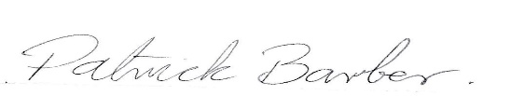September 12th 2023
Patrick Barber(Safeguarding Director)

