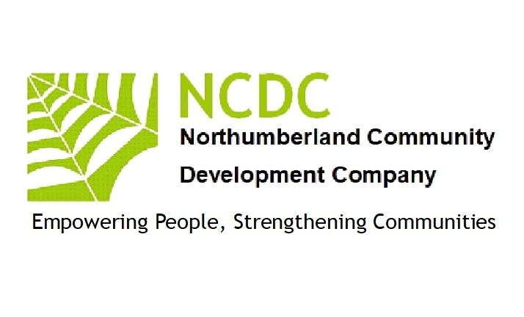
Volunteer Policy
Introduction and Scope
NCDC recognises the significant and valuable role that volunteers play in supporting us to achieve our aims. This policy reflects our commitment to ensuring the volunteer is integrated into the heart of NCDC, that volunteering with us is a constructive and rewarding experience and that all volunteers are treated in an equal, fair and just manner. This policy sets out to provide guidance to staff and volunteers and outline procedures and support mechanisms available to volunteers. It defines the term “volunteer” and provides a framework of best practice which we will endeavour to follow when appointing, managing and supporting our volunteers.

Definition of the Relationship
Volunteers are individuals or groups who offer their time, experience, knowledge and skills without financial gain beyond reimbursement of expenses; helping us to achieve our aims. There is no contract of employment between NCDC and its volunteers and volunteers are not considered employees of NCDC

NCDC Commitment to the Volunteer
NCDC views its volunteers as a valuable resource and is committed to providing support and recognition of their input. Volunteers are supported through the provision of resources necessary to complete their duties; induction and appropriate training and a supervision commitment. Volunteer contributions are recognised through written references (where appropriate), invitation to special events and opportunities to feedback to the development of volunteer management at NCDC. Volunteers have the right to refuse any request made of them and are not bound by contract, but are obliged to volunteer in line with Volunteer Policy and the Volunteer Agreement.

Commitment of the Volunteer
NCDC expects volunteers to behave in a manner which reflects positively on the organisation and to promote the key organisational messages where possible. NCDC expects volunteers to execute agreed duties, unless otherwise informed, and requests that volunteers carry out in the name of the NCDC only those tasks approved by supervising staff. NCDC expects volunteers to be supportive of staff, other volunteers and of the NCDC ethos and aims. We would ask that all volunteers volunteering on a regular basis to please, where possible, give us four weeks’ notice if they are considering leaving their volunteering role. We also ask that volunteers attending irregularly to please give us at least one week’s notice if you are not able to attend a scheduled event.

Principles
This Volunteer Policy is underpinned by the following principles
- NCDC will endeavour to ensure volunteers are properly integrated into its organisational structure, that they are kept abreast of organisational developments and that necessary mechanisms are in place for them to contribute to our work. NCDC Volunteer Policy does not aim to introduce volunteers to replace paid staff.
- NCDC recognises that volunteers require satisfying work and personal development opportunities and will seek to help volunteers meet these needs.
- NCDC expects staff to work positively with volunteers.

Recruitment and Selection
NCDC recruitment and selection of volunteers is designed to ensure that we recruit volunteers who are suitable for the role they would like to do:
- NCDC will provide volunteer role descriptions which outline duties and responsibilities.
- Prior to appointment, volunteers are invited to engage in a two-way discussion of the proposed role including its requirements and expectations with a view to assessing mutual suitability.
- Commencement of the volunteering opportunity is subject to either a relevant Criminal Record Disclosure and reference clearance.
- Volunteers may be subject to a probationary or trial period of 1-2 months depending on the role.
- Support, guidance and supervision are provided as appropriate.

Disclosure of Criminal Record
Due to the nature of our work all volunteers, aged 16 years or older, are subject to a criminal record disclosure as part of the recruitment process. NCDC complies fully with the code of practice provided by Disclosure England, Access NI and the Disclosure and Barring Service and undertakes to treat all volunteer applicants fairly in line with our commitment to equal opportunities and to comply with the Rehabilitation of Offenders Act 1974. Our Criminal Record Disclosure Policy which includes information about the recruitment of ex-offenders can be made available to all applicants during the recruitment process.

Equal Opportunities and Diversity
NCDC is committed to promoting equal opportunities. Volunteering opportunities at NCDC are open to all regardless of age, race, disability, ethnic origin, gender, marital status, nationality, national origin, race, religion, sexual orientation, pregnancy or maternity. NCDC recognises the positive benefits a diverse volunteer pool can bring to the organisation and is committed to ensuring our recruitment and selection procedure reflects this.

Disabled Volunteers
NCDC promotes diversity in all areas of volunteering. We encourage disabled people, in particular, to volunteer with us. All the venues that we use are fully accessible and we may be able to provide extra support when required for expenses(please liaise with the Volunteer Manager about this prior to volunteering). We would ask where possible, for volunteers to bring their own carers and support workers if required, as we have a limited budget for volunteer expenses. The carer or support worker would need to provide a recent criminal record disclosure certificate prior to attending a NCDC event. Disabled volunteers can act as role models and mentors to the young wheelchair users that we work with and may inspire them during their journey towards independence. Disability should not be a barrier to volunteering and volunteers can still claim benefits as long as you are aware of the restrictions explained in the ‘Volunteering while getting benefits’ leaflet produced by the Department for Work and Pensions.

Induction and Training
All volunteers will receive a general orientation on the nature and purpose of the organisation as well as task specific training to ensure they can carry out their work on behalf of NCDC effectively and efficiently.
Confidentiality
Volunteers are responsible for maintaining the confidentiality of all privileged information to which they are exposed. Failure to maintain confidentiality may result in termination of the volunteer’s relationship with the organisation.

Support and Recognition
All volunteers will have a named supervisor responsible for the management of their work, who is there to provide guidance and assistance. Those engaged in more sustained volunteering will have more formal supervision sessions at agreed intervals. These sessions shall be conducted via email, phone or face-to-face as appropriate and agreed. Supervising staff will review the volunteering placement as often as required, with the aim of ensuring that recognition keeps apace with role development. NCDC is happy to provide a confirmation of contribution for volunteers who have given a minimum of a full week of their time or a reference for those contributing over longer, sustained periods.

Procedure for Claiming Expenses
All claims must be made using the Volunteer Expenses Claim Form – only fully completed forms with receipts attached will be accepted. The form must be signed by the volunteer and returned to the volunteer’s supervisor for authorisation and then sent to the Volunteer Manager at HQ. Payment of authorised expenses is made by BACS transfer directly into the volunteer’s bank account (N.B. full bank, or building society, account details must be completed on the (Volunteer Expenses Claim Form for this to be processed). Expenses are paid to volunteers in the middle and at the end of each calendar month.
Concerns and Complaints
NCDC is committed to the welfare of our volunteers and we believe that any concerns brought to light at an early stage can be dealt with in an informal manner between volunteer and Supervisor. In the unlikely event that a dispute cannot be resolved in this manner, the Volunteer Manager can
be involved. All volunteers have the opportunity to feedback to the Volunteer Manager through evaluation forms or meetings, depending on the volunteer role.
You can contact the Volunteer Manager by calling 07885 303166 or emailing
info@ncdc.org.uk johnM@ncdc.org.uk

The above policy was reviewed and updated by the Board of Directors (NCDC)

Signed September 12th 2023

Patrick Barber (Director NCDC)

