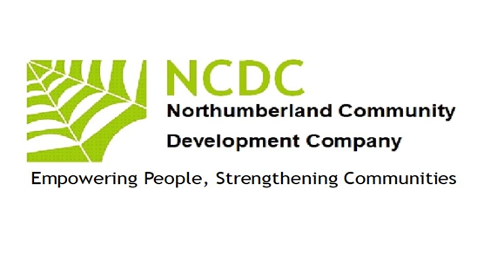
Empowering People
Strengthening
Communities
Empowering People
Strengthening
Communities
Annual Report 2024 –2025

Chairman’s report
This year has seen NCDC manage several complementary projects for which we raised funds from several sources.
I would like to thank everyone who has helped NCDC through this year of transition our delivery team have delivered magnificent results. Annette McGlade has nurtured a team of enthusiastic volunteers, NCDC is grateful for their contributions of time, skills and expertise and to my colleagues on the board who have increased their commitment to steer the organisation forward helping spread our impact in the locality together with regular activity leaders, James Oates, Alison Broomhead & Richard MacDonald. We will continue to deliver quality community learning.
I would also thank our funders who include, Lotto, Northumberland County Council, Karbon. Our Board, during a five-year strategic plan is now ready to grow our organisation. We are focusing on our existing strengths in Inclusion, Learning, Networking and Economic Enterprise
We have continued to focus the majority of our work in the sparse rural areas of the county replacing services and activities stripped out through centralisation of resources by public sector funders. By sparse we interpret that through the resident densities of between 3-11 people per square kilometre
We are working with local people to develop skills and capacity to run sustainable programmes of learning. Wellbeing, Health and leisure and Connecting Communities through Local History. Of course, the passed lockdowns through COVID 19 have a legacy which needs lots of change but NCDC is prepared to accept the challenges. If you would like to find out more about working with NCDC, please contact me. Patrick Barber, Chair. 07748040100

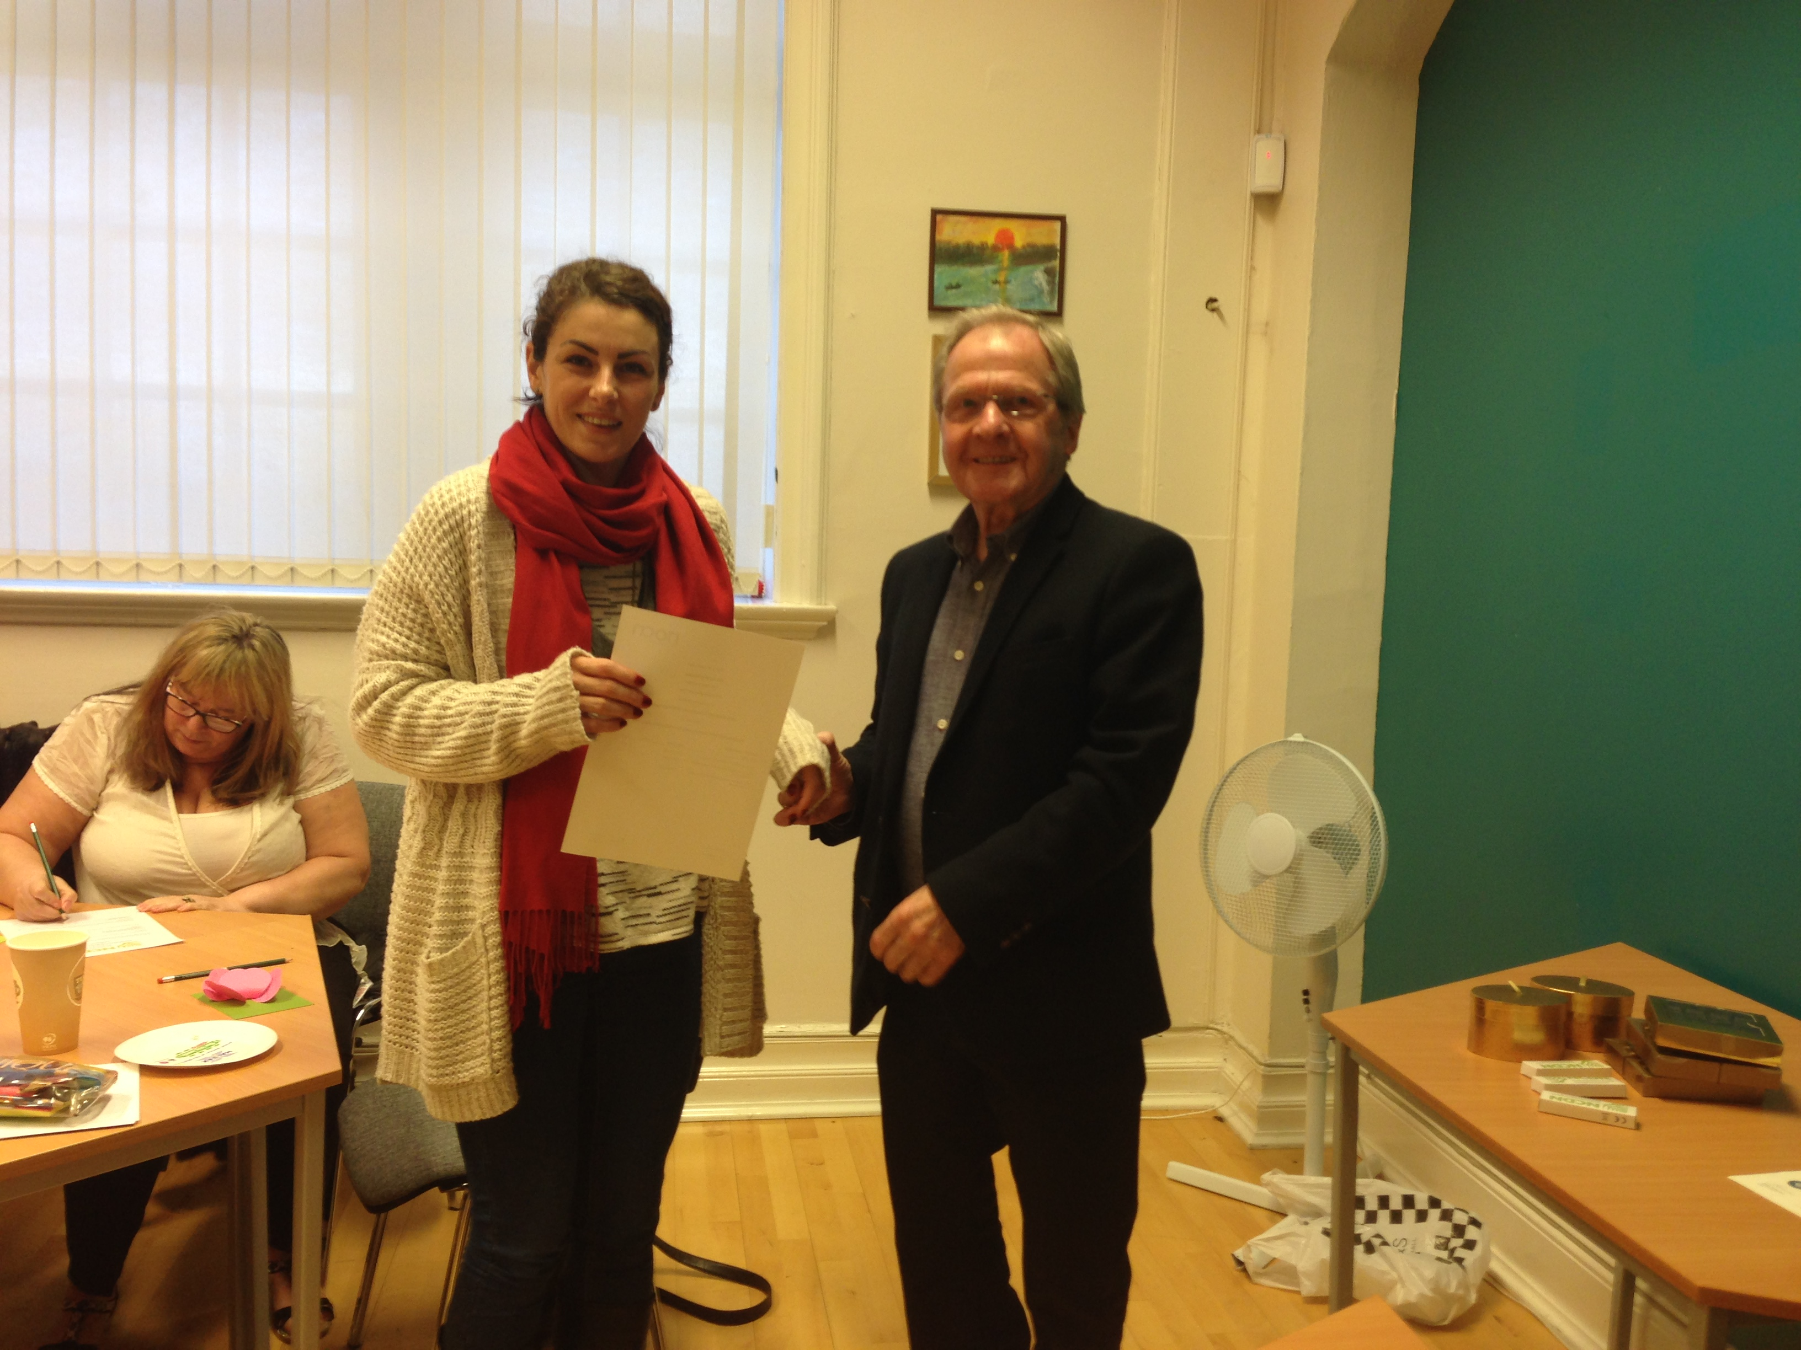

Pat Barber
John McGough

Jim Robertson

Our Work 2024-2025
Inclusion
NCDC is a champion of rural services activity alongside Community Action Northumberland. We are focused on working in the very sparsely populated areas in the south west of the county, which often have little or no public transport, virtually no adult learning, debt advisory services more than 20 miles away, and with a population which is becoming isolated and somewhat destitute through the lack of public service provision. We are working with local people to assist them provide services they want within easy travel /time. Our work has supported two village hall committees strengthen their membership, skills, and offers to their local residents
Networking
Whilst locally we are developing enterprise and community networks NCDC is also involved countywide in the VCS networks through which major policy can be seen to emerge. We are elected on the VCS Assembly Executive as representatives for the west of the county and on VONNE’S VCSE focus group which through its relationship with the NELEP informs and works alongside public sector partners in designing and delivering services for the counties/regions residents. We have also assisted Northumberland Care/NCC in their new Locality posts by meeting up and providing detailed local information. Our All-Aboard project brought the tiny hamlets and villages in the outer west together exploring Local History and produced a beautiful poster which has been distributed to residents
Learning
NCDC is a registered training organisation for NOCN (previously the National Open College Network) and One Awards and continues to offer training and support to individuals in skills involved in developing communities. We worked with learners from remote areas in West Northumberland to offer an Award in Community Development. This was successful with most gaining a qualification.
On a diverse cultural thread two of our team supported and curated an online art exhibition with over a dozen local artists relating to our rural environment. This is still active as a U-Tube link as due to COVID we have yet been unable to take it on tour in local community venues. The link is https://www.youtube.com/watch?v=68o_X8PeieM
Economic Enterprise
Collaborating with local residents we have undertaken two research projects through which we have identified needs, skills, local business ideas and generated a culture of organisations working to generate their own sustainable wealth rather than be completely reliant on grant funding. We have reported locally on the Skills needs in the hospitality sector and in rural/farming businesses We have offered specific business support, mentoring, marketing expertise to assist new rural business to thrive. This is now developing into a local marketplace for business-to-business trading thus reducing economic leakage of wealth. NCDC has been a visible force in raising a campaign banner for rural community.

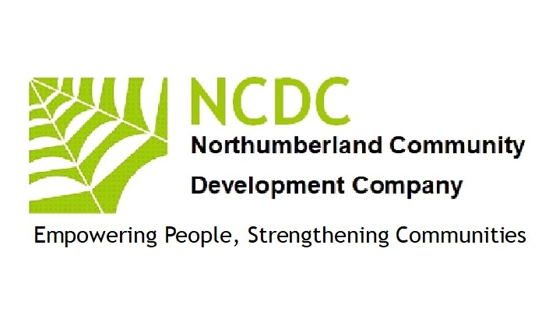
Minutes
2024/25 AGM for Northumberland community Development company took place on Friday 10th October at Three Tuns, Heddon on the Wall. It started at 12.30 and ended at 2.30pm
…………………………………………………………………..
Agenda:
- Accounts 2024/25:
The account were presented and reviewed by the board and accepted.
- Funding:
The Chair reported that two grants were awarded by Lotto and HCSF
- Nomination of Directors:
The board appointed four new directors.
Annette McGlade. Lynn Toson. Maureen Lawrie and Jame Oates
- Policies:
The board was informed that the company polices where fully up to date and available on request.
- Website/Social Media:
The board was informed that the Website and Social Media sites were up to date and popular.
- Any other Business:

Patrick Barber (Treasurer) issued a warning that company would close March 2027 if no grants were found.
Annette McGlade is now the new Safeguarding office for NCDC.
The chair is now to be managed by two senior Directors. Jim Robertson and Patrick Barber.
Maureen Lawrie has suggested for the next meeting, looking at alterative way of raising capital.

In Attendance: Annette McGlade. Maureen Lawrie. Jim Roberson. James Oates. Patrick Barber

